Custom GATT Service Constructor (v1.1)

**Supports only SDK5.0.4 !!!**

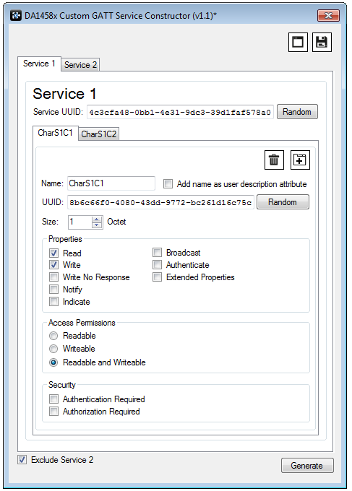Service Tabs

Save Services XML

Load Services XML

Characteristic Tabs

Add Characteristic

Delete Characteristic

Builds only Service 1

Generate .c and .h file

!!! If you save your Services XML file in the “custom-profile” folder of your SDK504 project, then the c and h file will default to that folder when you click “Generate”:

…\DA1458x_SDK\5.0.4\projects\target_apps\template\<your_project>\src\custom_profile

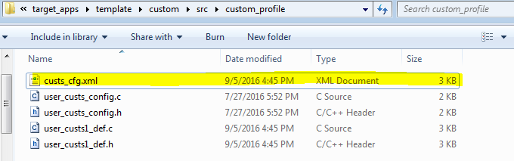

Services XML file

These files are constructed

!!! Use space characters in you characteristic names such as “Room Temperature”. This will ensure that your user description attributes are user friendly. The constructor will automatically convert the characteristic names into code friendly names such as “room_temperature” and “ROOM_TEMPERATURE”.